**Measurement Systems**

**LAB 6: Design of notch filter for ECG and EEG.**

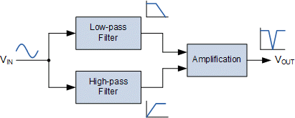

A notch filter (also known as a bandstop filter or reject filter) is defined as a device that rejects or blocks the transmission of frequencies within a specific [frequency](https://www.electrical4u.com/fundamental-frequency-and-harmonics/) range and allows frequencies outside that range. Notch filters eliminate transmission of a narrow band of frequencies and allow transmission of all the frequencies above and below this band. As it eliminates frequencies hence, it is also called a band elimination filter.

A notch filter is essentially a band stop filter with a narrow stopband and two passbands. As in the [band-pass](https://www.electrical4u.com/band-pass-filter/) case, a band-reject filter can be either wideband or narrow-band.

**Circuit Diagram-**

